ReactJS Hands On Learning – 03

Folder Structure:
Src

Components Stylesheets
-CalculateScore.js -mystyle.css

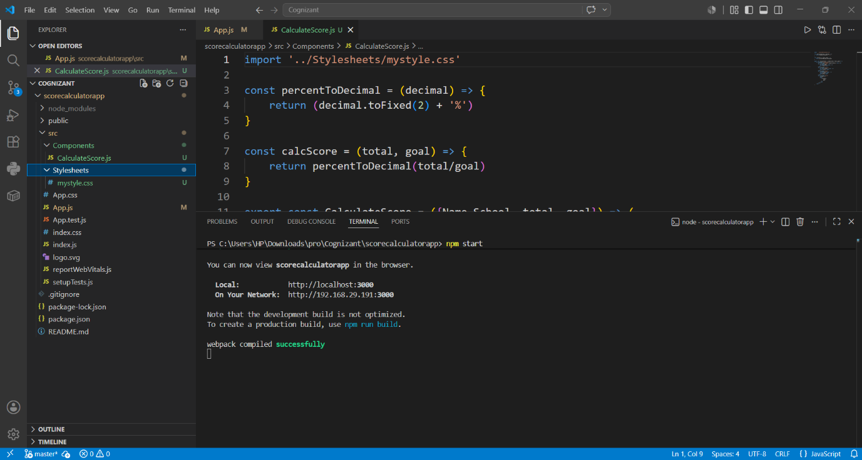

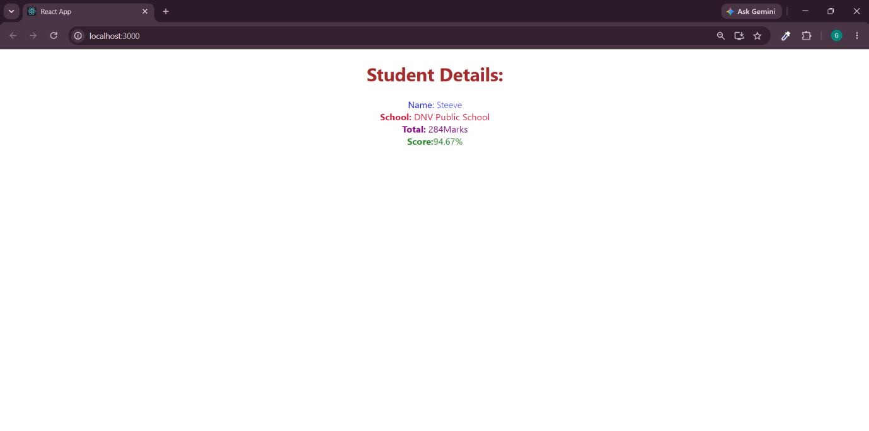
Output

